**Drive installation method as shown in the following picture:**

1. We need to open the installation package:**Uart drive(CH340)**,

2.We need to double click to **CH341SER.EXE,** as shown in the following picture.

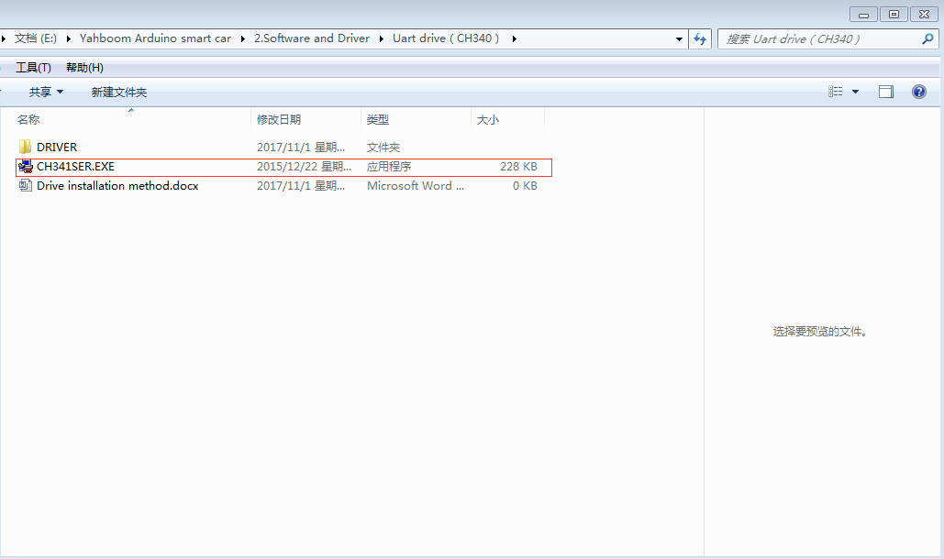3.We need to double click to "**INSTALL**"**,** as shown in the following picture.

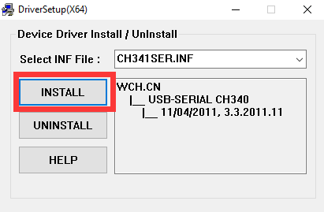

1. We need to click "OK" to install the  driver  successfully.
2. 3. Connect the UNO board to the computer with the USB cable. Then open the computer device manager and you will recognize the corresponding CH340 port, as shown below:

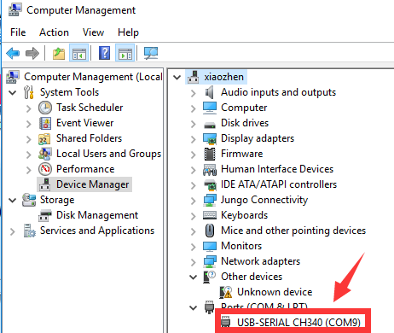

**Note: The port number of each computer will be different, as long as it recognizes that CH340 is the port we need.**